# 1. Architecture

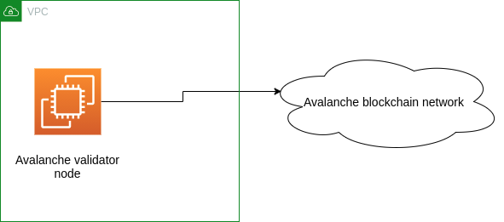

# 

# 2. Create Security groups

Please create the followings security groups:

## 2.1. mainnet-avax

Inbound rules:

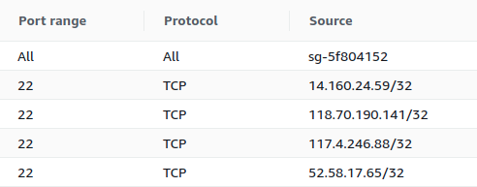

# 3. Setup mainnet-avax full node

## 3.1. Create Instance

Create an EC2 instance:

* AMI: Ubuntu Server 20.04 LTS (HVM), SSD Volume Type
* Type: t3.xlarge
* Storage: 150G General purpose SSD
* Security groups: default, ssh, maninet-avax

## 3.2. Install Prerequisites

Login to the server and run the following commands:

| wget [https://github.com/ava-labs/avalanchego/releases/download/v1.4.2/avalanchego-linux-amd64-v1.4.2.tar.gz](https://github.com/ava-labs/avalanchego/releases/download/v1.3.2/avalanchego-linux-amd64-v1.3.2.tar.gz)  tar -xvf avalanchego-linux-amd64-v1.4.2.tar.gz |
| --- |

## 3.3. Start node

| cd /etc/systemd/system/  sudo vim avalanche.service  sudo chmod 644 avalanche.service  sudo systemctl daemon-reload  sudo systemctl enable avalanche |
| --- |

Create a avalanche.service file with the following content:

| [Unit]  Description = Avalanche node service  Wants = network-online.target  After = network-online.target  [Service]  User = ubuntu  Group = root  Type = simple  ExecStart = /bin/bash -c '/home/ubuntu/avalanchego-v1.4.2/avalanchego --http-host=0.0.0.0 --dynamic-public-ip=ifconfig'  KillSignal=SIGINT  RestartKillSignal=SIGINT  TimeoutStopSec=2  LimitNOFILE=32768  Restart=always  RestartSec=5  [Install]  WantedBy = multi-user.target |
| --- |

Start cardano full node:

| sudo systemctl start avalanche |
| --- |

Or check the syncing status:

| journalctl --unit=avalanche --follow |
| --- |

# 5. Setup Validator on avax node

## 5.1. Check bootstrapping status

To check if a given chain is done bootstrapping, in another terminal window call info.isBootstrapped by copying and pasting the following command:

| curl -X POST --data '{  "jsonrpc":"2.0",  "id" :1,  "method" :"info.isBootstrapped",  "params": {  "chain":"X"  }  }' -H 'content-type:application/json;' 127.0.0.1:9650/ext/info |
| --- |

If this returns true, the chain is bootstrapped. If you make an API call to a chain that is not done bootstrapping, it will return API call rejected because chain is not done bootstrapping

## 5.2. Create a Keystore User

Avalanche nodes provide a built-in **Keystore.** The Keystore manages users and is a lot like a wallet. A user is a password-protected identity that a client can use when interacting with blockchains. **You should only create a keystore user on a node that you operate, as the node operator has access to your plaintext password.** To create a user, call keystore.createUser:

| curl -X POST --data '{  "jsonrpc": "2.0",  "id": 1,  "method": "keystore.createUser",  "params": {  "username": "YOUR USERNAME HERE",  "password": "YOUR PASSWORD HERE"  }  }' -H 'content-type:application/json;' 127.0.0.1:9650/ext/keystore |
| --- |

The response should be:

| {  "jsonrpc":"2.0",  "result":{"success":true},  "id":1  } |
| --- |

## 5.3. Create an Address

Avalanche is a platform of heterogeneous blockchains, one of which is the X-Chain, which acts as a decentralized platform for creating and trading digital assets. We are now going to create an address to hold AVAX on our node.

To create a new address on the X-Chain, call avm.createAddress, a method of the X-Chain’s API:

| curl -X POST --data '{  "jsonrpc":"2.0",  "id" :2,  "method" :"avm.createAddress",  "params" :{  "username":"YOUR USERNAME HERE",  "password":"YOUR PASSWORD HERE"  }  }' -H 'content-type:application/json;' 127.0.0.1:9650/ext/bc/X |
| --- |

The response should look like this:

| {  "jsonrpc":"2.0",  "id":2,  "result" :{  "address":"X-avax1xeaj0h9uy7c5jn6fxjp0rg4g39jeh0hl27vf75"  }  } |
| --- |

## 5.4. Add a validator with Avalanche Wallet

First, we show you how to add your node as a validator by using [Avalanche Wallet](https://wallet.avax.network/).

Get your node’s ID by calling [info.getNodeID](https://avalanche.gitbook.io/avalanche/build/apis/info-api#info-getnodeid):

| curl -X POST --data '{  "jsonrpc":"2.0",  "id" :1,  "method" :"info.getNodeID"  }' -H 'content-type:application/json;' 127.0.0.1:9650/ext/info |
| --- |

The response has your node’s ID:

| {  "jsonrpc": "2.0",  "result": {  "nodeID": "NodeID-5mb46qkSBj81k9g9e4VFjGGSbaaSLFRzD"  },  "id": 1  } |
| --- |

Open [the wallet](https://wallet.avax.network/), and go the Earn tab. Choose Add Validator.

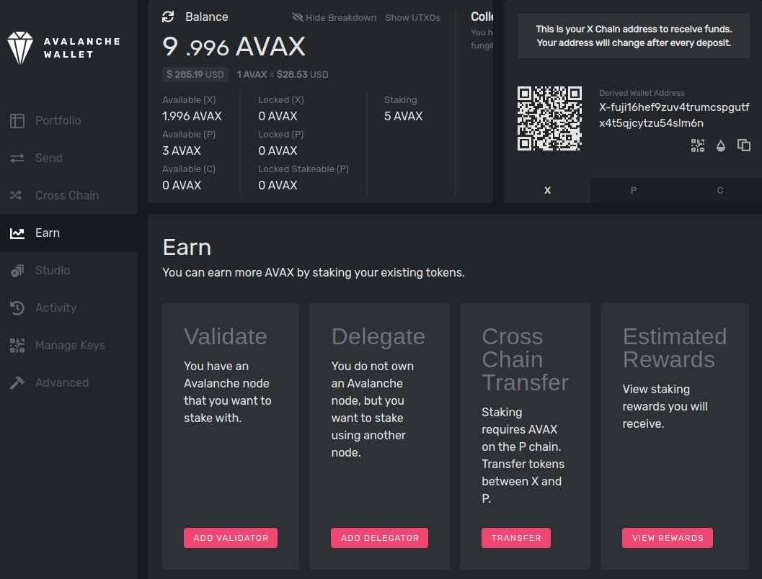

Fill out the staking parameters. They are explained in more detail below. When you’ve filled in all the staking parameters and double-checked them, click Confirm. Make sure the staking period is at least 2 weeks, the delegation fee rate is at least 2%, and you’re staking at least 2,000 AVAX.

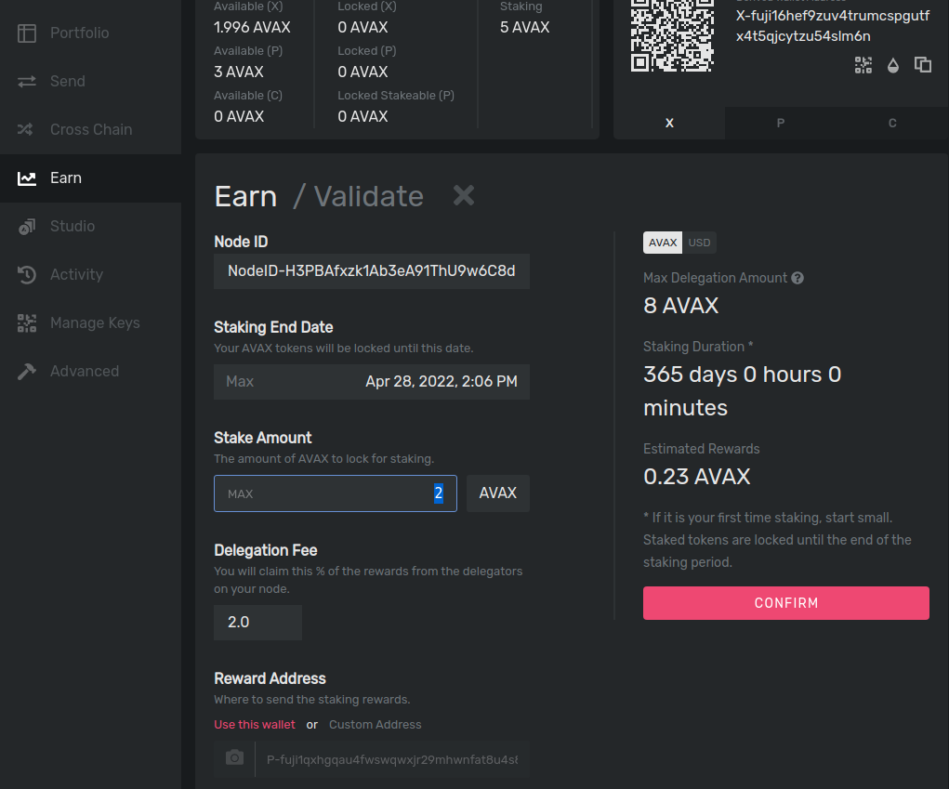

Go back to the Earn tab, and click Estimated Rewards.

